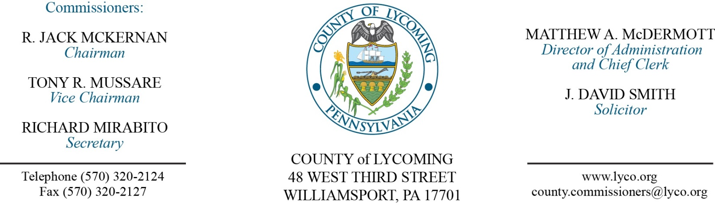
Commissioners’ Meeting Agenda
October 27, 2016

Opening Prayer

Pledge to the Flag

1.0 OPERATIONS

1.1 Convene Commissioners’ meeting.

1.2 Approve the minutes of the previous meetings.

1.3 Receive public comments (agenda items only).

Recess Commissioners’ Meeting

Final Public Hearing for 2016 CDBG

Kristin McLaughlin

Reconvene Commissioners’ Meeting

2.0 ACTION ITEMS

2.1 Adopt resolution 2016-24 for CDBG application. (Kristin McLaughlin)

2.2 Approve budget modification to FFY 2015 CDBG program. (Kristin McLaughlin)

2.3 Adopt resolution 2016-25 for Fair Housing for CDBG. (Kristin McLaughlin)

2.4 Approve FFY 2015 CDBG contract between State/DCED. (Kristin McLaughlin)

2.5 Approve purchase of ScanPro 2000 microfilm scanner from DRS Imaging Group in the amount of $12,268. (Kristin McLaughlin)

2.6 Approve 3rd amendment to lease agreement with US Department of Agriculture. (Mya Toon)

2.7 Approve child welfare education for leadership (CWEL) agreement with the University of Pittsburgh, School of Social Work to provide paid tuition for one CYS Caseworker for the purpose of obtaining a Masters in Social Work (MSW) degree. (Mya Toon)

2.8 Approve agreement with Diakon Family Life Services for JPO. (Nancy Ackley)

2.9 Approve agreement with Highway Equipment & Supply Company for the purchase of 1- New Volvo L350F Articulating Wheel Loader with accessories and the trade-in for a total of $521,604.

2.10 Approve professional service agreement with Deacon Equipment Company, Inc. (Jason Yorks)

2.11 Approve TDA changes - RMS – Resource Recovery - change Collection Supervisor to Resource Recovery Supervisor; PCD – remove GIS Graphics/Field Work Coordinator position, reclassify GIS/Data Systems Analyst grade 7/8 position to GIS Analyst grade 8/9, reclassify GIS Supervisor/Technician grade 8/9 position to grade 9/10. (Roxanne Grieco)

2.12 Approve the following personnel actions: (Roxanne Grieco)
Prison – Becky J. Steppe as full time replacement Clerk III – Pay grade 4 - $18.176809/hour effective 11/6/16.
PCD – reclassification of Amy M. Fry as full time GIS Supervisor/Technician – Pay grade 10 - $26.41/hour effective 11/6/16.
PCD – reclassification of Edward Feigles as full time GIS Analyst – Pay grade 9 - $28.85/hour effective 11/6/16.

Recess Commissioners’ Meeting

3.0 SALARY BOARD

3.1 Convene Salary Board.

3.2 Approve update to salary schedule:
RMS – Resource Recovery - change Collection Supervisor to Resource Recovery Supervisor; PCD – remove GIS Graphics/Field Work Coordinator position, reclassify GIS/Data Systems Analyst grade 7/8 position to GIS Analyst grade 8/9, reclassify GIS Supervisor/Technician grade 8/9 position to grade 9/10.

3.3 Adjourn Salary Board.

Reconvene Commissioners’ Meeting

5.0 REPORTS/INFORMATION ITEMS

5.1 Recognize Wayne Benson upon his retirement.

5.2 LCRMS is requesting bids for seed fertilizer and erosion control. (Jason Yorks)

5.3 Lycoming County is requesting bids for Food Products 1st half 2017. (Mya Toon)

5.4 Lycoming County is requesting bids for Bread Products 1st half 2017. (Mya Toon)

6.0 COMMISSIONER COMMENT:

7.0 PUBLIC COMMENT:

8.0 NEXT REGULARLY SCHEDULED MEETING: Planning Session on Tuesday, November 1, 2016.

9.0 ADJOURN COMMISSIONERS’ MEETING.

